Causes of earthquakes – case study Haiti earthquake 2010
There are two key areas to research and understand in this section – the general causes of earthquakes and the causes of the Haiti earthquake 2010.
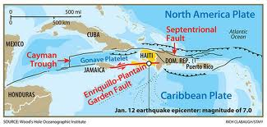
Key questions to answer in this section –
- What are the main causes of earthquakes?
- What were the main causes of the Haiti earthquake 2010?
You MUST know and complete the following –
- The plate boundaries at which earthquakes occur – Constructive, Destructive, Conservative and Collision plate boundaries. You will need a fully labelled diagram of each one and you will need to describe each plate boundary. You should also include a world map that shows you where these plate boundaries are located.
- The main physical processes that occur along these plate boundaries - what makes them move and how they move, what happens when they move?
- What is meant by the magnitude of an earthquake and be very clear that this can vary – give examples of different magnitudes of earthquakes (including Haiti 2010)
- How earthquake magnitude is measured and recorded on the Richter Scale and the Modified Mercalli Intensity Scale – you will need to say what each one is, how they are different from one another and a diagram of each one.
- The location of Haiti in the world and in the Caribbean. You will need maps to show this and a brief description of its location. Your Haiti map should show the epicentre of the 2010 earthquake and the plate names and boundaries that triggered the 2010 earthquake. Make sure you also mention the focus of the earthquake and what impact this had on Haiti in 2010.

Make sure you understand all the earthquake terms you come across in this section.
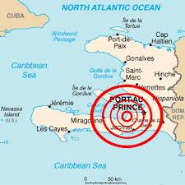

You will need to research this information from the key websites provided and any others you may come across.

General websites to aid your research on causes of earthquakes
http://www.bbc.co.uk/schools/gcsebitesize/geography/natural_hazards/earthquakes_rev1.shtml
http://www.geography-site.co.uk/pages/physical/earth/cause.html
http://www.earthquake.usgs.gov/learn/kids/eqscience.php
www.ga.gov.au/hazards/earthquakes/earthquake-basics/causes.html
http://www.en.wikipedia.org/wiki/Earthquake
www.fostercity.org/faqs/earthquake-cause.cfm

Causes of Haiti earthquake 2010 websites
http://www.geographyalltheway.com/recent-geography/haitian-earthquake.htm
www.geography.learnontheinternet.co.uk/topics/haiti_earthquake.html
Plate boundaries websites
http://www.s-cool.co.uk/gcse/geography/tectonics/revise-it/plate-boundaries
http://www.sln.org.uk/geography/schools/blythebridge/gcserevisionplatestheory.htm

Measuring and recording Magnitude of earthquakes
http://en.wikipedia.org/wiki/Richter_magnitude_scale
http://schools.matter.org.uk/content/Seismology/richterscale.html
http://www.geo.mtu.edu/UPSeis/intensity.html
http://earthquake.usgs.gov/learn/topics/mercalli.php
http://quake.abag.ca.gov/shaking/mmi/

Good luck with this! Remember that if you are not sure about anything just ask your geography teacher – we are here to help!!!

