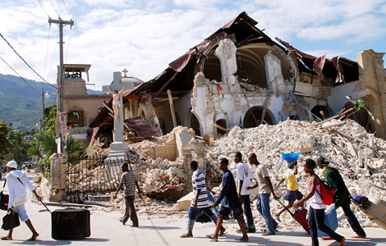
How were the impacts of the 2010 Haiti earthquake event managed?

Key idea - The impact of earthquakes can be managed over the short and long term

As you have seen from the previous pages, the Haiti earthquake is currently ranked as the 2nd most deadly earthquake ever recorded. With an estimated three million people affected by the quake the Haitian government reported that approximately 316,000 people had died. 300,000 had been injured and 1,000,000 made homeless. The government of Haiti also estimated that 250,000 residences and 30,000 commercial buildings had collapsed or were severely damaged. The management of this disaster in the hours, days and weeks (short term) after the event: and in the months and years ahead (long term) would require careful management if the severe impacts were to be reduced.

What were the short-term management strategies?

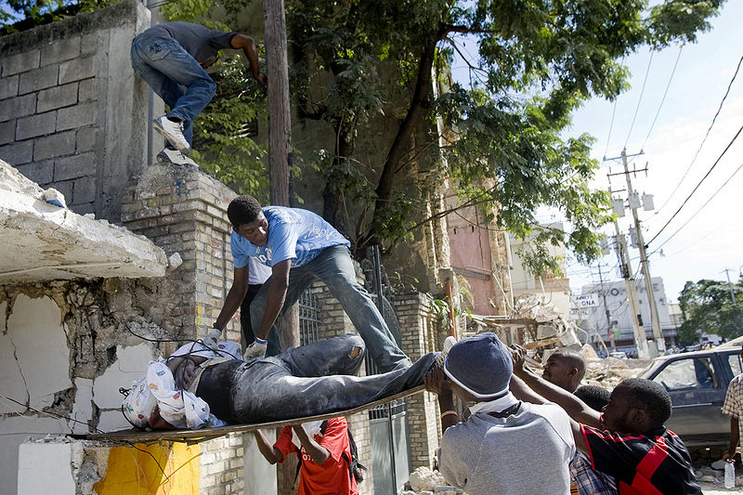
As Haiti is a less economically developed country (LEDC), the government had limited resources, capital and expertise to be able to manage the effects of such a large humanitarian disaster. For the first 24 hours after the earthquake it was a case of the general public pulling together to do what they could to search for survivors and those trapped. This just involved people using their bare hands and torches. Even within the first 24 hours, dead bodies were quickly building up as many of the hospitals and morgues had been destroyed.
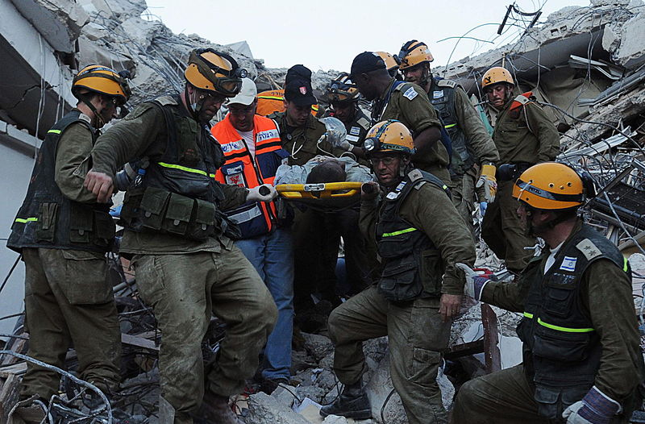
After 48 hours, when the true scale of the human suffering taking place became clear, the international community was quick to respond to assist the Haitian government. Several governments and charities sprang into action...

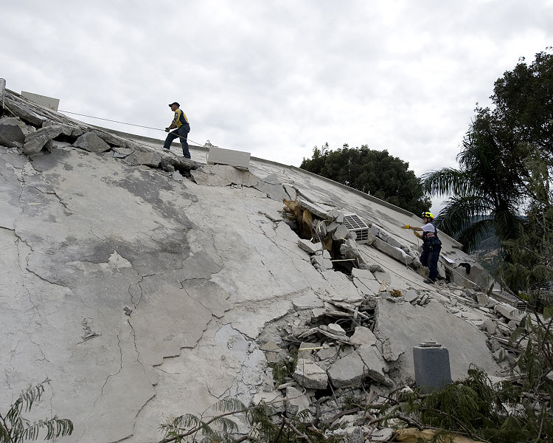
The Dominican Republic was the first country to give aid to Haiti, sending water, food and heavy-lifting machinery. The Dominican Republic also sent eight mobile medical units along with 36 doctors and surgeons. In addition, 39 trucks carrying canned food were dispatched, along with 10 mobile kitchens and 110 cooks capable of producing 100,000 meals per day.

The earthquake emergency team to arrive in Port-au-Prince was ICE-SAR from Iceland, landing within 24 hours of the earthquake. From the Middle East, the government of Qatar sent a strategic transport aircraft (C-17), loaded with 50 tonnes of urgent relief materials and 26 members from the Qatari armed forces.
The International Charter on Space and Major Disasters was activated, allowing satellite imagery of affected regions to be shared with rescue and aid organizations.

The American Red Cross set a record for mobile donations, raising US$7 million in 24 hours when they allowed people to send US$10 donations by text message.

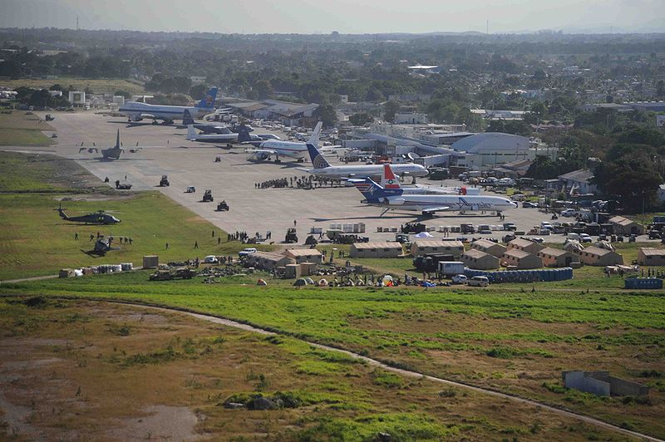
Over the first weekend 130,000 food packets and 70,000 water containers were distributed to Haitians, as safe landing areas and distribution centers such as golf courses were secured. There were nearly 2,000 rescuers present from 43 different groups, with 161 search dogs; the airport had handled 250 tons of relief supplies by the end of the weekend.

One major issue was that several key government buildings had been destroyed and several important members of the government were trapped or missing. This led to a feeling that the immediate relief effort lacked leadership. Nobody knew who was actually in charge and this made the co ordination of all the help flooding in difficult. When this became apparent, the US government took over control of the major airport, to help direct the aid arriving in Haiti.

One major short term response which was required was what to do with all the dead bodies. The morgues in Port au Prince could not cope with the number of dead bodies so several large mass graves had to be dug to bury the ever increasing number of dead people. Many people were shocked at the decision to create mass graves and burn large numbers of corpses. Max Beauvoir, a local priest, protested the lack of dignity in mass burials, stating,

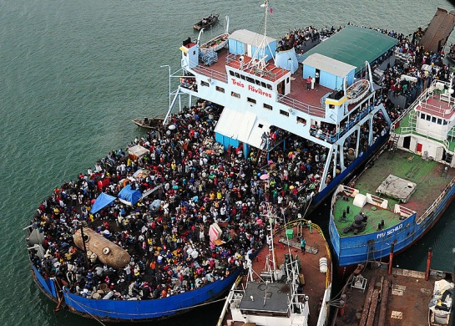
"... it is not in our culture to bury people in such a fashion, it is desecration".

Those who were able to, left the city behind and fled to towns in the Eastern Dominican Republic. While to government there was keen to help their Haitian neighbours, their hospitals were soon filled with people from Haiti. The Dominican Republic sent soldiers to monitor the border between the two countries explaining that they would help but that the Haitians could only stay temporarily to get medical help.

What were the long-term management strategies?

Much money and support from all corners of the globe has been pledged to help the people of Haiti recover from this disaster. In order help the recovery as quickly as possible, the government are concentrating the US $5.3 billion pledged for Haiti's reconstruction on three main strategies.

Firstly, they need to improve the infrastructure and design housing by using modern technology. Prior to the earthquake, Haiti had no effective building regulations. Although some of the urban centres in Haiti are exceptionally densely populated, the buildings were constructed in such a way that meant they were unable to withstand the ground shaking. Also, the lack of regulations also meant that many buildings were likely to help spread fire. This poor building design is one of the primary factors which made this earthquake so deadly. In order to minimise the loss of life for future earthquakes to date 236 construction teams have been trained in order to ensure that new buildings have better fire protection and are less likely to collapse in the event of an earthquake and over 340,000 houses have been structurally assessed since the earthquake. This video shows a little of what the future might be like for Haiti homes http://youtu.be/N_JShtBVOfE

At some point in the future there will be another earthquake in Haiti. All the Government can do in the long term is aim to reduce the risk of death. With this in mind the Government hope to improve their current earthquake monitoring and warning systems. Haiti’s first seismic monitoring network has recently been installed. The network monitors and locates aftershock earthquakes — producing information critical to understanding the earthquake hazard in Haiti.
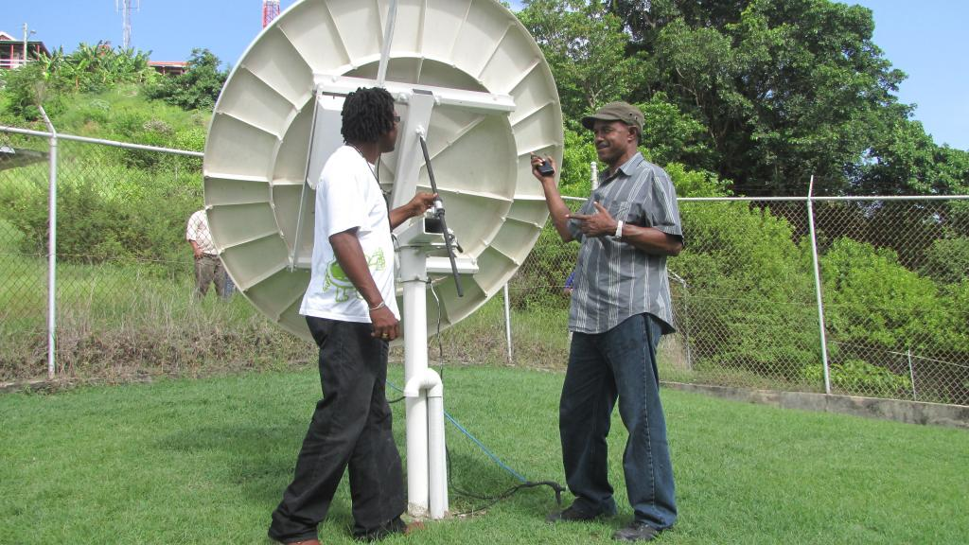
Consisting of three monitoring stations located in Port-au-Prince, Jacmel and Léogâne, the network detects tremors along the Enriquillo-Plaintin Garden Fault, the fault that ruptured during the main 2010 earthquake. Each station continuously broadcasts the data via satellite. The information is then shared with the U.S. Geological Survey (USGS), which helps to detect and accurately locate the earthquakes.
With increasing numbers of scientists monitoring movements and stresses building up in the plate boundary, the Government hope to be able to accurately predict when another earthquake is likely. It is hoped this information will help the government draw up safe zones and evacuation plans should another earthquake appear likely. However, scientists are still not able to perfectly predict where and when an earthquake will occur. You can read more about this monitoring network here http://www.nrcan.gc.ca/science/story/3577

The final long term strategy is to provide education on emergency procedures
for the general public so they know what to do in the event of an earthquake. Investing in this kind of education has helped to reduce the risk of death for many places across the Earth which are prone to Earthquakes. For example, in the USA and Japan the Government invests much money in educating people on what to do when disaster strikes. So far in Haiti, training has been provided for 13,000 teachers and teaching staff to help educate the population on how to stay safe before, during and after an earthquake event. This training involves practical actions individuals can take such as,

- Identifying the safe places in a room such as under a strong desk, along interior walls, and also which places to avoid such as near windows, large mirrors, hanging objects, heavy furniture and fireplaces

- Stocking up on emergency supplies. These include: battery operated radio (and extra batteries), flashlights (and extra batteries), first aid kit, bottled water, two weeks food and medical supplies

- Store flammable liquids away from potential ignition sources such as water heaters, stoves and furnaces

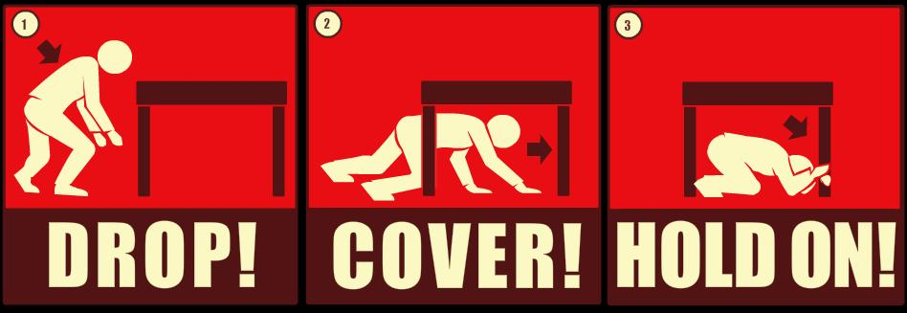
- During an earthquake quickly move to a safe location in the room such as under a strong desk, a strong table, or along an interior wall. The goal is to protect yourself from falling objects and be located near the structural strong points of the room

- Avoid taking cover near windows, large mirrors, hanging objects, heavy furniture, heavy appliances or fireplaces

- If you are cooking, turn off the stove and take cover

- If you are outdoors, move to an open area where falling objects are unlikely to strike you. Move away from buildings, power lines and trees.
Haiti Voices
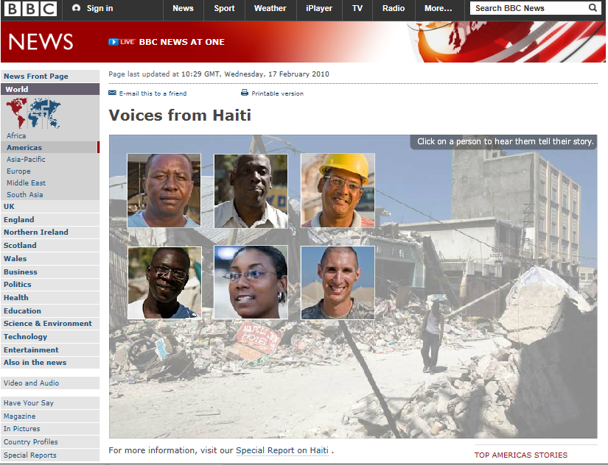
This website http://news.bbc.co.uk/1/hi/world/americas/8518856.stm provides you with an opportunity to hear short video extracts from a range of people affected by and responding to the Haiti Earthquake.
What is the latest now? Has everything been returned to normal? Watch this video from the BBC filmed in January 2012 on Haiti Two years on http://www.bbc.co.uk/news/world-latin-america-16527435 and now read this report from November 2012 http://www.bbc.co.uk/news/world-latin-america-20320487
Create a mind map which shows the responses to the Haiti Earthquake. You should have two main branches, one for short term and one for long term responses. Ensure you follow these “rules” for mind mapping and illustrate your branches with at least three responses. Include key statistics from the text above.

Key Exam questions

- Using a named example of a recent earthquake hazard you have studied, describe the short and long term responses to the hazard. (6 marks)

- “Earthquakes are always more deadly in LEDC’s than MEDC’s”. Using examples you have studied, evaluate the extent to which would you agree with this statement. (8 marks)
This website may help you compare the Haiti earthquake with other recent earthquake events http://news.bbc.co.uk/1/hi/world/americas/8510900.stm
- Do you feel optimistic or pessimistic about the future earthquake risk in Haiti. Explain why you feel this way. (6 marks)

